

WREXHAM SWIMMING CLUB
AFFLIATED TO THE WELSH AMATUER SWIMMING ASSOCIATION


14th Spring Meet 2017

Level 2
License No 2WL170791

29th April and 30th April 2017

UNDER FINA TECHNICAL RULES AND SWIM WALES LAWS

Wrexham Swimming Club would like to thank Dee Valley Water for their kind sponsorship this season


MEET INFORMATION

Wrexham Waterworld
LL13 8DH
The home of Wrexham Swimming Club

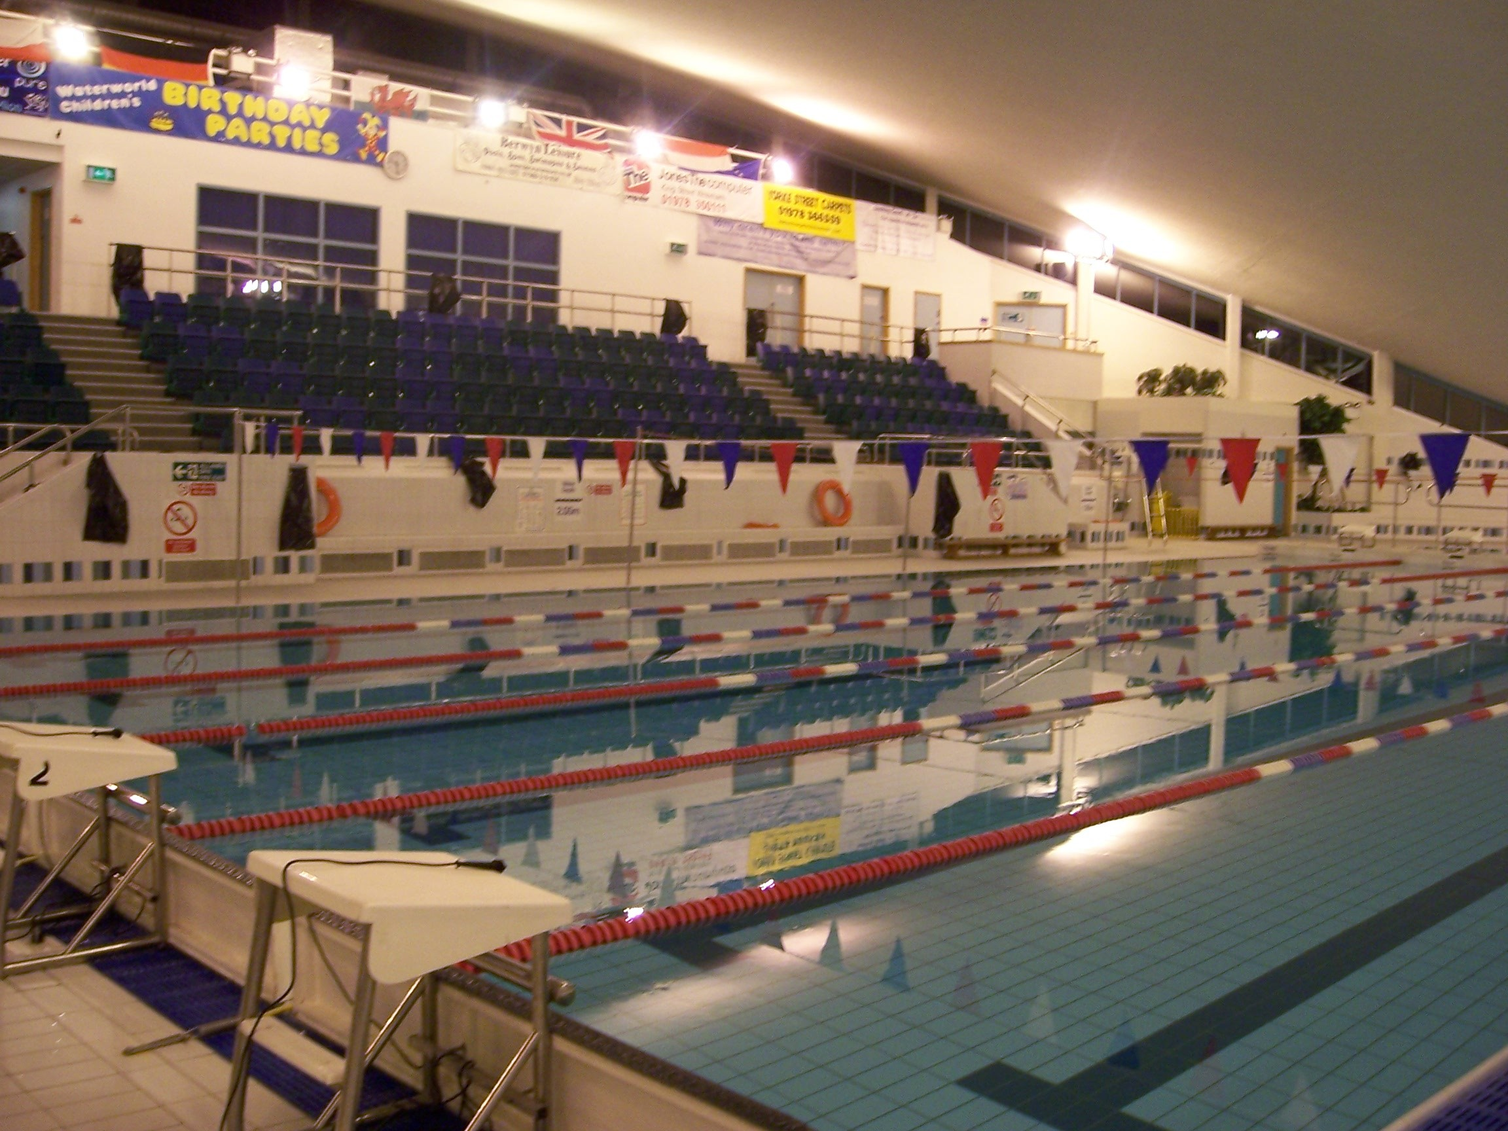

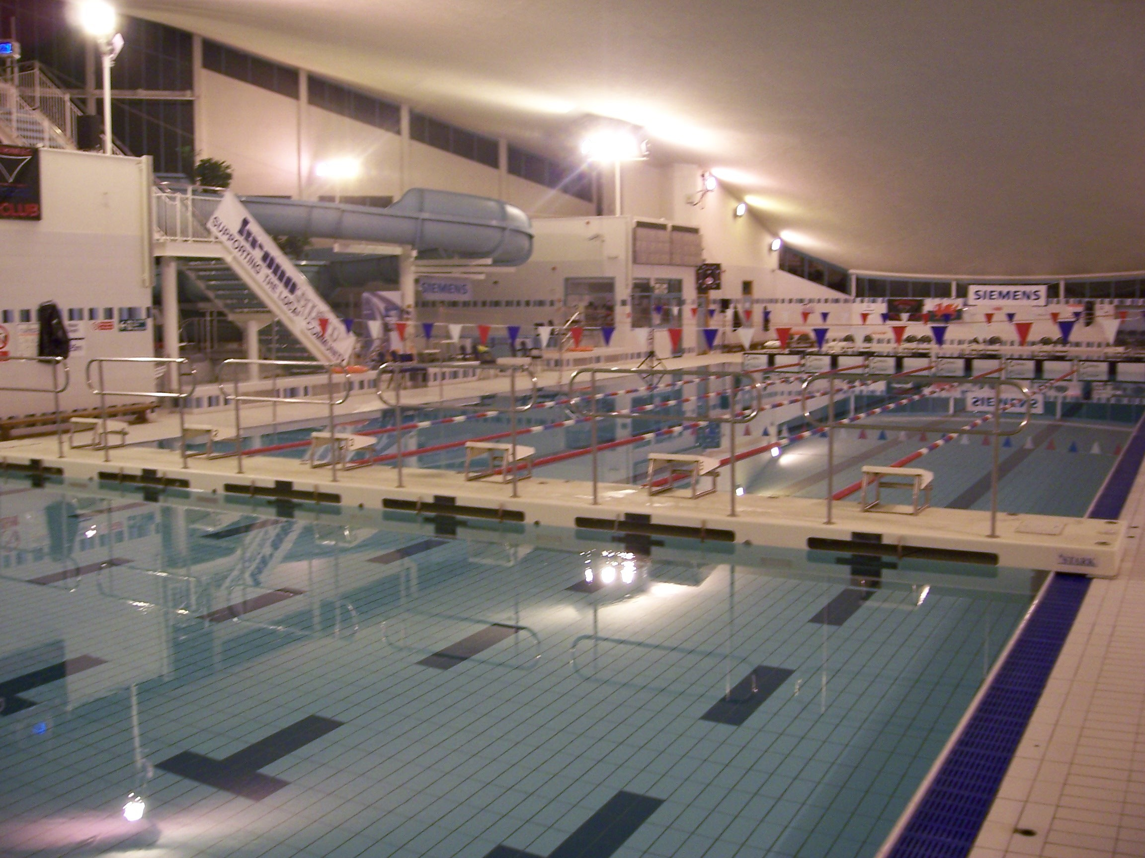

14th Spring Meet 2017 - 29/04/2017 to 30/04/2017
Session Report
Session: 1 Saturday Morning

Finals 1 Girls 10 & Over 200 IM
Finals 2 Boys 10 & Over 200 IM
Finals 3 Girls 10 & Over 100 Breaststroke
Finals 4 Boys 10 & Over 100 Breaststroke
Finals 5 Girls 10 & Over 50 Backstroke
Finals 6 Boys 10 & Over 50 Backstroke

Session: 2 Saturday Afternoon

Finals 7 Girls 10 & Over 400 Freestyle
Finals 8 Boys 10 & Over 400 Freestyle
Finals 9 Girls 10 & Over 50 Butterfly
Finals 10 Boys 10 & Over 50 Butterfly
Finals 11 Girls 10 & Over 200 Butterfly
Finals 12 Boys 10 & Over 200 Butterfly

Session: 3 Saturday Evening

Finals 13 Boys 10 & Over 200 Freestyle
Finals 14 Girls 10 & Over 200 Freestyle
Finals 15 Boys 10 & Over 100 Butterfly
Finals 16 Girls 10 & Over 100 Butterfly

Session: 4 Sunday Morning

Finals 17 Boys 10 & Over 200 Backstroke
Finals 18 Girls 10 & Over 200 Backstroke
Finals 19 Boys 10 & Over 50 Freestyle
Finals 20 Girls 10 & Over 50 Freestyle
Finals 21 Boys 10 & Over 400 IM
Finals 22 Girls 10 & Over 400 IM
Finals 23 Boys 10 & Over 100 Backstroke

Session: 5 Sunday Afternoon

Finals 24 Girls 10 & Over 100 Backstroke
Finals 25 Boys 10 & Over 50 Breaststroke
Finals 26 Girls 10 & Over 50 Breaststroke
Finals 27 Boys 10 & Over 100 IM
Finals 28 Girls 10 & Over 100 IM

Session: 6 Sunday Evening

Finals 29 Girls 10 & Over 200 Breaststroke
Finals 30 Boys 10 & Over 200 Breaststroke
Finals 31 Girls 10 & Over 100 Freestyle
Finals 32 Boys 10 & Over 100 Freestyle

- The meets will be run under FINA Technical Rules and Swim Wales Laws.
- 25 metre, 6 lane deck level pool with anti-turbulence lane ropes.
- Electronic timing, with manual back up in the event of breakdown.
- Warm up & swim down facility, dependant on numbers.

- Cafeteria open all day.

- We are pleased to announce that Liakada Photography will be in attendance at the meet. The photographer will be taking general shots of all competitors. All shots that are taken are stored onto a memory card. At the end of each event the photos from the memory card will be downloaded onto a computer and then transferred onto individual iPads for viewing. All photos are available for inspection approximately 10 minutes after each event. The photos are not published online and are not placed onto a website or social media. An occasional image of a club hat shot where the swimmer is not identifiable may be put onto social media or given to the club for club promotional purposes. A team shot may also be given to the club for media or website use. The images are stored for 12 months and then deleted. The photographer and the assistant on the photography stand have up-to-date enhanced DBS certificates. If you do not wish your child to be photographed, please make this known to the Liakada Photography staff on the stand.

- Age on last day of competition applies. (Minimum age on day of swim 10 years)
- Coach’s signature on entry form confirms correct entry time and swimmers ability to dive i.e. attained a level of the Competitive Start Award.. Swimmers unable to perform such a dive must start in the water
- It is the responsibility of visiting Clubs to inform us of any medical conditions of swimmers competing, that we need to be made aware of.

- This is a level two licensed meet and will be run on a first received first entered basis. If the meet fills up to the safe working limit of the pool the meet will be closed at an earlier date at the discretion of Wrexham SC. We urge clubs not to arrange Hotel or B&B bookings until you have received confirmation of your entries as if the closing date is brought forward this could involve you in cancellation fees. The 400m freestyle and 400m IM may have further restrictions put on them because of the time limits set for this meet. In previous years we have restricted it to one heat for each age group on fastest qualifying basis once entries have been accepted.

- Only swimmers with times equal to or faster than the consideration times (CT) listed later are eligible for this meet. We do not accept entries with No Times. We will not process any entries which come in after the meet closing date unless it is a mistake on our part.

- No card entry system
- Withdrawal forms and a telephone number will be made available for each meet. Withdrawals must be advised to the meet office ½ an hour before the start of each session.
- Entry fee £4.50 for electronic entries or £5.00 for manual entries. Wrexham SC will only take a single club cheque for entries and coaches passes, we will not accept entries with individual parent’s cheques.
- We prefer clubs to transfer their entry fees by BACS Transfer to:-

Sort Code 40-47-26

Account Number 12109093

Reference SPRING followed by your club’s code

- Closing date for entries Saturday 8th April 2017
- Any refunds of entry fees against withdrawals prior to competition will be considered on an individual basis. No refunds will be considered during the week prior to competition.
- Medals for the top six swimmers in each age group of the event 10,11,12,13,14,15 and 16/over
- Whilst we will make every effort to adhere to the published programme of events, Wrexham SC reserve the right to make any changes found to be necessary

- £5-00 spectator/daily entry fee

- Coaches pass available at £12 for weekend without lunches £24 for weekend with lunch each day

- As this meet involves persons under the age of 18, the use of ALL photographic equipment is controlled. Such equipment shall not be used without first registering your name, address and telephone number at the entrance control. You will be asked to identify yourself and expected to display a pass which will be provided free of charge. Wrexham Swimming Club will retain the records of camera use.

- FOR ELECTRONIC ENTRIES PLEASE CONTACT MR BOB ROGERS 01978 291095

HEALTH & SAFETY

- The health, safety and wellbeing of all swimmers, officials, volunteers, spectators and visitors is paramount – all Health and Safety rules / regulations/ requirements must be complied with at all times.
- A full risk assessment must be carried out in accordance with the Swim Wales Meet License Report Pack.
- A copy of the Pool Operating Procedures and / or the Normal Operating Procedures & Emergency Action Plan for the facility being hired for a meet must be obtained in advance, and must be available throughout the duration of meet

All swimmers, officials, volunteers, spectators, and visitors are required, at all times, to abide by the rules set out in the Pool Operating Procedures and / or the Normal Operating Procedures & Emergency Action Plan for the facility hired for the meet.
- Unacceptable Behavior
Behavior becomes “unacceptable” when it is considered “Offensive” to others; this includes, but is not limited to, the following:

Theft, willful damage to property and / or equipment, acts of vandalism, abuse of alcohol and / or drugs, bullying, offensive language, aggressive / violent acts, threatening behavior, all breaches of safety practices, failure to comply with instructions / directions, actions that bring the sport of swimming into disrepute.
- Competitive Start Award
Swimmers must have attained the standard of the Competitive Start Award in order to start from the blocks; (this is the responsibility of the club coach).

Swimmers who have not attained the standard of the Competitive Start Award must lower themselves into over the side into the water, on the long whistle of the Referee before starting at an appropriate place.
- Jewellery
“For safety and security reasons, the wearing of jewellery is not permitted while in the water during warm-ups / swim-downs and / or competition. This includes watches, necklaces, chains, bangles, wrist bands, ear-rings (except studs), and rings (except wedding bands).

Swim Wales will not be responsible for any jewellery brought to events and will not be liable if such jewellery is lost or damaged.”
- Video and Photography.
When a competition involves children under the age of 18 years of age it is a mandatory meet license requirement that all persons (including competitors / officials / volunteers / spectators), wishing to engage in any kind of photographic activity including video, zoom, close range photography, irrespective of the nature of the device / equipment used for taking / recording such images must register their details with the event management in advance of taking any images.

This includes; but is not limited to :

Still cameras
Cine Cameras
Video cameras
Camera / video enabled mobile phones
Camera enabled PDA’s

Proof of identity is required to register any photographic / video equipment.

Coaches / Team Manager Passes for Wrexham Meets
Please list below details of persons wishing to have poolside passes at our meets. Only those people detailed below are allowed to be with the teams on poolside.

Name…………………………………….. Name………………………………………..

Address………………………………….. Address……………………………………..

…………………………………………… ………………………………………………

…………………………………………… ………………………………………………

…………………………………………… ………………………………………………

ASA/WASA number…………………….. ASA/WASA number………………………...

Name………………………………………. Name…………………………………………..

Address……………………………………. Address………………………………………..

……………………………………………… …………………………………………………

……………………………………………… …………………………………………………

………………………………………………. ……………………………………………….

ASA/WASA number………………………… ASA/WASA number…………………………

Club………………………………………………………………………………………………………

The persons detailed above are all currently CRB checked by our club and are authorised by us to act as Coaches/Team Managers

Secretary or Chairman…………………………………………………………………………Please sign
Girls | Ages | 10 | 11 | 12 | 13 | 14 | 15 | 16/o
Event
Event 1 Girls 200 IM |  | 4:03.20 | 3:31.70 | 3:24.80 | 3:17.40 | 3:12.30 | 3:08.40 | 3:06.10
Event 3 Girls 100 Brst |  | 2:03.40 | 1:53.40 | 1:46.20 | 1:41.10 | 1:38.50 | 1:37.40 | 1:36.80
Event 5 Girls 50 Back |  | 51.56 | 48.09 | 45.68 | 44.00 | 42.42 | 41.27 | 40.74
Event 7 Girls 400 Free |  | 7:11.30 | 6:38.40 | 6:18.30 | 6:03.80 | 5:54.30 | 5:48.70 | 5:44.50
Event 9 Girls 50 Fly |  | 49.25 | 45.57 | 43.06 | 40.95 | 39.90 | 38.75 | 38.12
Event 11 Girls 200 Fly |  | 4:00.80 | 3:36.40 | 3:23.40 | 3:14.00 | 3:07.70 | 3:05.10 | 3:02.40
Event 14 Girls 200 Free |  | 3:25.70 | 3:17.70 | 3:01.30 | 2:54.10 | 2:49.50 | 2:46.00 | 2:44.10
Event 16 Girls 100 Fly |  | 1:48.90 | 1:38.40 | 1:32.30 | 1:28.30 | 1:25.40 | 1:24.30 | 1:23.50
Event 18 Girls 200 Back |  | 3:51.30 | 3:33.90 | 3:22.00 | 3:14.90 | 3:09.70 | 3:06.90 | 3:03.00
Event 20 Girls 50 Free |  | 43.58 | 41.58 | 39.48 | 37.80 | 36.54 | 35.70 | 35.39
Event 22 Girls 400 IM |  | 8:19.80 | 7:35.50 | 6:50.90 | 6:39.30 | 6:29.40 | 6:21.70 | 6:16.60
Event 24 Girls 100 Back |  | 1:49.00 | 1:40.60 | 1:34.30 | 1:31.20 | 1:28.90 | 1:27.70 | 1:26.70
Event 26 Girls 50 Brst |  | 57.12 | 53.34 | 50.09 | 47.78 | 46.10 | 45.05 | 44.52
Event 28 Girls 100 IM |  | 1:47.30 | 1:43.00 | 1:37.80 | 1:33.20 | 1:30.90 | 1:29.30 | 1:26.70
Event 29 Girls 200 Brst |  | 4:23.70 | 4:02.20 | 3:48.80 | 3:38.10 | 3:31.20 | 3:28.00 | 3:26.60
Event 31 Girls 100 Free |  | 1:36.40 | 1:27.70 | 1:23.80 | 1:20.10 | 1:18.60 | 1:17.40 | 1:16.50
Boys | Ages | 10 | 11 | 12 | 13 | 14 | 15 | 16/o
Event
Event 2 Boys 200 IM |  | 3:49.60 | 3:33.60 | 3:21.60 | 3:10.00 | 2:58.90 | 2:51.70 | 2:47.10
Event 4 Boys 100 Brst |  | 2:03.80 | 1:53.30 | 1:45.60 | 1:38.90 | 1:34.10 | 1:30.40 | 1:27.50
Event 6 Boys 50 Back |  | 51.56 | 48.20 | 45.15 | 42.63 | 40.22 | 38.33 | 37.17
Event 8 Boys 400 Free |  | 7:11.60 | 6:33.80 | 6:17.60 | 5:58.90 | 5:42.00 | 5:31.30 | 5:21.40
Event 10 Boys 50 Fly |  | 48.72 | 45.68 | 42.53 | 40.01 | 37.91 | 35.81 | 34.86
Event 12 Boys 200 Fly |  | 3:58.10 | 3:35.70 | 3:21.40 | 3:09.90 | 2:59.80 | 2:52.30 | 2:47.70
Event 13 Boys 200 Free |  | 3:25.40 | 3:11.30 | 2:59.40 | 2:50.00 | 2:42.00 | 2:36.50 | 2:31.30
Event 15 Boys 100 Fly |  | 1:47.40 | 1:38.20 | 1:31.10 | 1:25.80 | 1:21.20 | 1:17.70 | 1:15.40
Event 17 Boys 200 Back |  | 3:40.20 | 3:35.00 | 3:22.20 | 3:10.40 | 3:01.20 | 2:54.00 | 2:48.70
Event 19 Boys 50 Free |  | 46.47 | 41.27 | 38.75 | 36.65 | 34.65 | 32.76 | 31.71
Event 21 Boys 400 IM |  | 8:13.00 | 7:33.40 | 7:03.40 | 6:41.90 | 6:19.40 | 6:03.20 | 5:53.60
Event 23 Boys 100 Back |  | 1:48.60 | 1:40.50 | 1:34.00 | 1:28.40 | 1:23.60 | 1:20.40 | 1:18.20
Event 25 Boys 50 Brst |  | 57.65 | 53.76 | 49.56 | 46.41 | 44.10 | 41.79 | 40.74
Event 27 Boys 100 IM |  | 1:48.60 | 1:42.60 | 1:37.10 | 1:31.10 | 1:25.80 | 1:22.30 | 1:19.40
Event 30 Boys 200 Brst |  | 4:25.50 | 4:04.90 | 3:46.00 | 3:34.50 | 3:23.20 | 3:15.10 | 3:10.70
Event 32 Boys 100 Free |  | 1:34.70 | 1:27.90 | 1:22.00 | 1:17.60 | 1:14.30 | 1:11.40 | 1:09.30

Swimmers must have times equal to or faster than the above times to enter that event.
 Document No SWLM/102 revised July 11th 2010

Level 2 Meets Qualifying Times (A grade) Pool Length 25m
BOYS |  |  |  |  |  |  |  |  |  | GIRLS
 | 10 | 11 | 12 | 13 | 14 | 15 | 16 | 17 | Event |  | 10 | 11 | 12 | 13 | 14 | 15 | 16 | 17
 | 38 | 35.9 | 33.9 | 32.1 | 30.4 | 29.1 | 28.3 | 27.8 | 50m Free |  | 38.5 | 36.5 | 34.7 | 33.3 | 32.4 | 31.7 | 31.3 | 31.3
 | 1:22.9 | 1:17.8 | 1:13.2 | 1:08.9 | 1:05.4 | 1:03.1 | 1:01.2 | 1:00.1 | 100m Free |  | 1:24.6 | 1:18.7 | 1:14.3 | 1:11.5 | 1:09.5 | 1:08.3 | 1:07.1 | 1:06.9
 | 2:59.3 | 2:48.8 | 2:39.1 | 2:30.1 | 2:22.5 | 2:17.2 | 2:13.2 | 2:11.1 | 200m Free |  | 3:00.4 | 2:49.6 | 2:39.9 | 2:33.6 | 2:29.6 | 2:26.6 | 2:24.6 | 2:23.2
 | 6:18.0 | 5:53.3 | 5:34.0 | 5:16.4 | 5:01.5 | 4:50.1 | 4:42.1 | 4:36.7 | 400m Free |  | 6:22.2 | 5:52.9 | 5:33.0 | 5:20.5 | 5:12.5 | 5:06.2 | 5:03.1 | 5:00.5
 | 13:26.1 | 12:28.4 | 11:41.1 | 11:01.8 | 10:31.3 | 10:08.4 | 9:51.2 | 9:40.2 | 800m Free |  | 13:36.7 | 12:09.5 | 11:29.3 | 10:58.3 | 10:40.8 | 10:30.7 | 10:23.5 | 10:20.7
 | 25:54.8 | 23:50.5 | 22:01.7 | 20:52.8 | 19:55.5 | 19:13.8 | 18:40.6 | 18:21.9 | 1500m Free |  | 26:15.9 | 23:27.7 | 22:10.0 | 21:10.1 | 20:51.7 | 20:22.6 | 20:03.0 | 19:57.7
 | 49.6 | 46.5 | 43.7 | 40.7 | 38.6 | 36.8 | 35.6 | 35 | 50m Breast |  | 50 | 46.7 | 44 | 42.1 | 40.8 | 39.8 | 39.4 | 39.1
 | 1:48.1 | 1:40.1 | 1:33.8 | 1:27.4 | 1:22.7 | 1:19.1 | 1:16.6 | 1:15.1 | 100m Breast |  | 1:48.8 | 1:40.2 | 1:34.4 | 1:29.8 | 1:26.5 | 1:25.1 | 1:24.3 | 1:23.1
 | 3:51.2 | 3:35.1 | 3:22.5 | 3:09.5 | 2:58.9 | 2:51.5 | 2:47.0 | 2:43.0 | 200m Breast |  | 3:51.5 | 3:34.9 | 3:22.4 | 3:12.8 | 3:06.7 | 3:03.5 | 3:01.6 | 3:00.2
 | 42.4 | 39.6 | 37.5 | 35.3 | 33.4 | 31.7 | 30.9 | 30.1 | 50m Fly |  | 42.4 | 40.1 | 37.9 | 36.4 | 35.2 | 34.4 | 34 | 33.9
 | 1:35.9 | 1:27.6 | 1:22.0 | 1:16.7 | 1:12.3 | 1:09.0 | 1:07.3 | 1:05.6 | 100m Fly |  | 1:36.0 | 1:28.0 | 1:22.4 | 1:19.0 | 1:16.3 | 1:15.1 | 1:14.1 | 1:13.3
 | 3:30.4 | 3:11.7 | 3:00.8 | 2:49.5 | 2:40.1 | 2:31.8 | 2:28.3 | 2:23.9 | 200m Fly |  | 3:32.8 | 3:13.9 | 3:00.7 | 2:52.6 | 2:46.7 | 2:43.0 | 2:41.2 | 2:39.3
 | 43.6 | 41.2 | 39 | 36.5 | 34.8 | 33.1 | 31.9 | 31.5 | 50m Back |  | 43.8 | 41.4 | 39.3 | 37.7 | 36.5 | 35.9 | 35.3 | 35.1
 | 1:34.7 | 1:27.6 | 1:22.5 | 1:17.3 | 1:13.0 | 1:09.8 | 1:07.8 | 1:06.3 | 100m Back |  | 1:35.2 | 1:28.1 | 1:22.7 | 1:19.2 | 1:17.0 | 1:15.3 | 1:14.4 | 1:14.0
 | 3:19.7 | 3:06.9 | 2:56.5 | 2:45.9 | 2:37.0 | 2:30.4 | 2:26.5 | 2:24.0 | 200m Back |  | 3:21.8 | 3:06.3 | 2:56.3 | 2:49.6 | 2:44.8 | 2:41.1 | 2:38.7 | 2:37.2
 | 3:25.1 | 3:11.0 | 3:00.5 | 2:50.4 | 2:40.7 | 2:34.3 | 2:30.3 | 2:27.3 | 200m IM |  | 3:25.6 | 3:11.4 | 3:00.6 | 2:53.8 | 2:48.7 | 2:45.5 | 2:43.4 | 2:42.0
 | 7:20.2 | 6:45.5 | 6:20.9 | 6:00.4 | 5:40.6 | 5:26.4 | 5:18.1 | 5:12.2 | 400m IM |  | 7:19.7 | 6:43.6 | 6:19.9 | 6:03.9 | 5:53.8 | 5:47.3 | 5:42.6 | 5:40.6
 | 1:36.2 | 1:30.9 | 1:26.0 | 1:20.7 | 1:16.0 | 1:12.9 | 1:10.3 | 1:09.0 | 100m IM |  | 1:35.1 | 1:31.3 | 1:26.4 | 1:22.6 | 1:20.6 | 1:19.1 | 1:17.6 | 1:17.2

These times are listed as a requirement by Swim Wales to be included in the meet pack as part of our Licence.

These times will not be taken into account as in the information previously given the meet is on a first received first entered basis.

14th Spring Meet Club entry form

Please use a separate entry form for Girls and Boys. Entry fee £5.00 per event manual entry, £4.50 per event electronic entry.
Return forms To:- Bob Rogers 3, Celmar Grove Rhostyllen Wrexham LL14 4BD including stamped self addressed envelope for confirmation of entries or include your email address. Closing date Saturday 8th April 2017

Club…………………………………. Address………………………………………………………………………..

Tel Number……………………… ……………………………………………………………………………

Name |  |  |  |  | D.O.B |  |  |  | Age |  |  | Reg,No
Freestyle |  |  |  | Backstroke |  |  |  | Breaststroke |  |  |  |  | Butterfly |  |  | Ind. Medley
50 | 100 | 200 | 400 | 50 |  | 100 | 200 | 50 |  | 100 | 200 |  | 50 | 100 | 200 | 100 |  | 200 | 400
Name |  |  |  |  | D.O.B |  |  |  | Age |  |  | Reg,No
Freestyle |  |  |  | Backstroke |  |  |  | Breaststroke |  |  |  |  | Butterfly |  |  | Ind. Medley
50 | 100 | 200 | 400 | 50 |  | 100 | 200 | 50 |  | 100 | 200 |  | 50 | 100 | 200 | 100 |  | 200 | 400
Name |  |  |  |  | D.O.B |  |  |  | Age |  |  | Reg,No
Freestyle |  |  |  | Backstroke |  |  |  | Breaststroke |  |  |  |  | Butterfly |  |  | Ind. Medley
50 | 100 | 200 | 400 | 50 |  | 100 | 200 | 50 |  | 100 | 200 |  | 50 | 100 | 200 | 100 |  | 200 | 400
Name |  |  |  |  | D.O.B |  |  |  | Age |  |  | Reg,No
Freestyle |  |  |  | Backstroke |  |  |  | Breaststroke |  |  |  |  | Butterfly |  |  | Ind. Medley
50 | 100 | 200 | 400 | 50 |  | 100 | 200 | 50 |  | 100 | 200 |  | 50 | 100 | 200 | 100 |  | 200 | 400
Name |  |  |  |  | D.O.B |  |  |  | Age |  |  | Reg,No
Freestyle |  |  |  | Backstroke |  |  |  | Breaststroke |  |  |  |  | Butterfly |  |  | Ind. Medley
50 | 100 | 200 | 400 | 50 |  | 100 | 200 | 50 |  | 100 | 200 |  | 50 | 100 | 200 | 100 |  | 200 | 400
Name |  |  |  |  | D.O.B |  |  |  | Age |  |  | Reg,No
Freestyle |  |  |  | Backstroke |  |  |  | Breaststroke |  |  |  |  | Butterfly |  |  | Ind. Medley
50 | 100 | 200 | 400 | 50 |  | 100 | 200 | 50 |  | 100 | 200 |  | 50 | 100 | 200 | 100 |  | 200 | 400

Total No of entries……………….X £5.00 =………………….. Confirm all swimmers are of the standard ……………….…………...Coaches Signature.
of the Competitive Start Award

